1. **Default name for bean when stereo types.  
   Case 01**:   
   @Component  
   class ReservationService{}: As we’ve not provided any bean id so the default one would be reservationService.   
   **Case 02**:  
   @Component  
   class REservationService{}: As we’ve not provided any bean id so the default one would be REservationService because if first 2 letters of class are capital, the same class name is used as bean id.Bean Scopes with Annotations.
   1. Lifecycle of a bean, How long, how many instances, how to share.
2. **Default scope:**Singletone (cached in memory)
   1. **How**

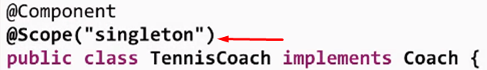



1. Bean lifecycle Methods/Hooks: Bean initialization, Bean Destruction.   
   **@PostConstruct  
   AccessModifier_Any return_Type_Any method_Name(MustBeVoid){}  
   @PreDestroy  
   AccessModifier_Any return_Type_Any method_Name(MustBeVoid){}  
   Exceptional Case:  
   @PostConstruct, @PreDestroy:** When Java9, or higher 🡺 compile time error as **javax.annotation** removed from default class path. So Download and add jar to your classpath.
2. **Initialization** methods are called for beans of all kinds of scopes but in case of **prototype**, destruction lifecycle callbacks are not called.  
   Solution: Register your own BeanPostProcessor (BeanPostProcessor, BeanFactoryAware, Disposable) identifying the scope to be prototype, registering them, calling their destroy method, in its destroy().See lecture 82.